LEGISLATIVE FACT SHEET

DATE: November 30, 2010 BT OR RC NUMBER: 2011-7
(Administration Bills)

SPONSOR (Department/Division/Agency/Council Member): Jacksonville Fire and Rescue Department

PURPOSE/SUMMARY:
In November, 2008, City Council adopted Ordinance 2008-656-E, a ten-year plan of improvements for the Jacksonville Fire and Rescue Department known as the Fire Study Report pursuant to Chapter 421 of the Ordinance Code adopted in 2001. Section 421.104 of the Ordinance Code places a requirement on the Mayor to include funding for the plan each year in his budget or to submit legislation explaining why funding was not included in his budget along with a revised plan for funding the improvements. Ordinance 2009-594-E was submitted and adopted last year pursuant to this requirement. The Mayor has determined that due to the serious financial problems continuing to face the City it is necessary to defer the majority of the FY2011 improvements to subsequent fiscal years. City Council is obligated by Section 421.105. of the Ordinance Code to review the Mayor’s revised plan of improvements.

Attached is a draft Ordinance for your consideration.

APPROPRIATION : Total Amount Appropriated: $ as follows:

(Name of Fund as it will appear in title of legislation)

Name of Federal Funding Source: Amount: $

Name of State Funding Source: Amount: $

Name of City of Jax Funding Source: Amount: $

Name of In-Kind Contribution Source: Amount: $

Name of Bond Acct Amount: $

Number

IMPACT - FINANCIAL/OTHER:

ACTION ITEMS:

Emergency? Yes No ____ Justification:
____________________________________________________________________________
Federal or State Mandates Yes No ____
Fiscal Year Carryover? Yes No ____
CIP Amendment? Yes No ____ (Attach CIP form)
Contract/Agreement (C/A) Approval Yes _____ No (Attach a copy only)
C/A negotiations on-going? Yes No ____
Oversight Department Required? Yes No ____ Name of Dept.
Related RC?/BT? Yes No ____ (Attach a copy)
Waiver of Code? Yes _____ No (Identify Code Provision______)
Code Exception? Yes No ____ (Identify Code Provision______)
Continuation Grant? Yes No ____
Surplus Property Certification? Yes No ____ (Attach a copy)
Related Enacted Ordinances? Yes X No ____ Ord. # of Previous Ord.2001-803-E
Ordinance 2008-656-E
Ordinance 2009-594-E
Report Required to City Council/Council Auditors
Yes____ No_____ Date_____ Frequency_____
ADMINISTRATION TRANSMITTAL

To: MBRC, c/o Roselyn Chall, Budget Division, Suite 325

CC: Adam Hollingsworth, Chief of Policy
Mayor's Office, Fourth Floor, City Hall at St. James
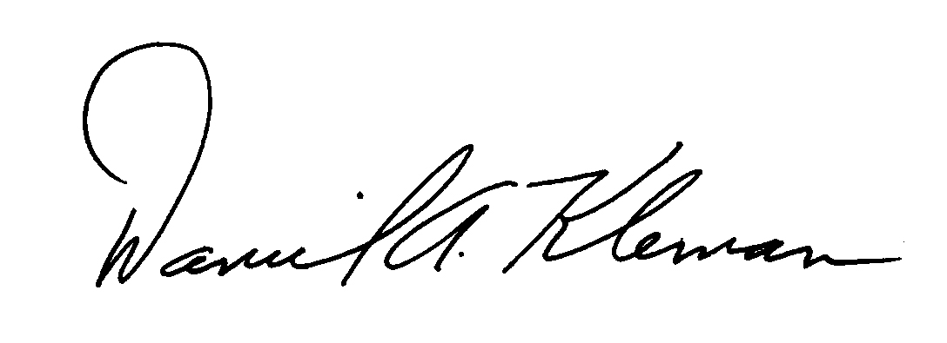

From: Daniel A. Kleman
Director/Fire Chief
Jacksonville Fire and Rescue Department
(Name, Job Title, Department)

Phone: 630-0568 Fax: 630-0521 E-mail: dkleman@coj.net

Contact person: Daniel A. Kleman
Director/Fire Chief
Jacksonville Fire and Rescue Department
(Name, Job Title, Department)

Phone: 630-0568 Fax: 630-0521 E-mail: dkleman@coj.net

____________________________________________________________________________________

COUNCIL MEMBER / INDEPENDENT AGENCY / CONSTITUTIONAL OFFICER TRANSMITTAL

To: James McCain, Office of General Counsel
City Hall at St. James

From:
(Name, Job Title, Department)

Phone: Fax: E-mail:

Contact person:
(Name, Job Title, Department)
Phone: Fax: E-mail:

Legislation from Independent Agencies requires a resolution from the Independent Agency Board approving the legislation.

FACT SHEET IS REQUIRED BEFORE LEGISLATION IS INTRODUCED

-2-

